Sexual Exploitation is NEVER Ok

Name
Institution
Professor
Date

Sexual Exploitation Is NEVER Ok
Sexual exploitation causes self-harm. The image below is that of a woman who has cut her hand as a way to manage the pain that has come with her being sexually exploited.
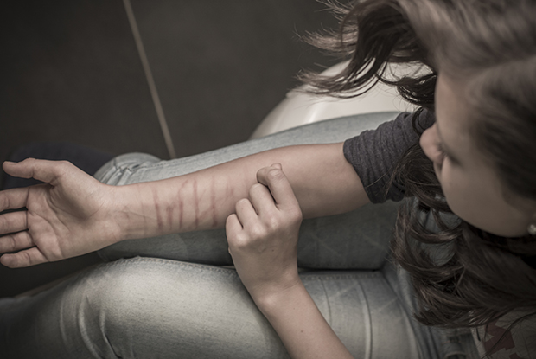https://cached.imagescaler.hbpl.co.uk/resize/scaleWidth/800/cached.offlinehbpl.hbpl.co.uk/news/PGH/iStock_000025145954_Double-2017042402155445.jpg
Self-harm resulting from sexual exploitation involves the victim deliberately hurting oneself by inflicting on herself physical harm in private. Interestingly, these self-harm techniques which could vary from burning oneself, hitting one’s body, biting oneself, cutting oneself, pulling out one’s hair, picking and scratching the skin, do not often lead to death as the victims hardly have suicidal thoughts while doing such acts. The lady in the image above is simply coping with the painful feelings she has after being exploited sexually. The lady is either trying to numb her pain, trying to regain some sense of control or trying to derive some relief from the exploitation trauma.
Sexually Transmitted Infections
Sexual exploitation can cause sexually transmitted infections which can either be bacterial or viral to either of the individuals involved in the act of sexual exploitation. These infections can be transmitted through anal, oral or vaginal contacts between two or more people. These infections are numerous as seen in the image below and each has different symptoms and effects. However, the infections can affect people of all social classes and age in discriminatively.

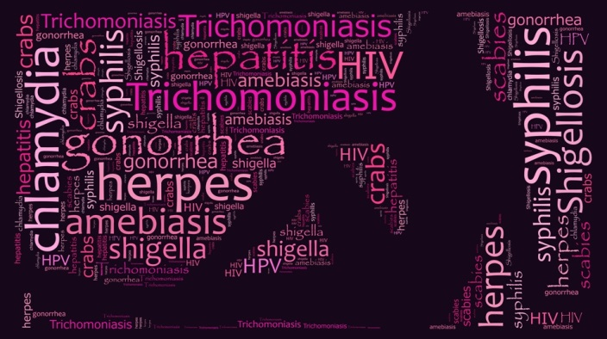 https://thewellproject.org/sites/default//files/STD.jpg
Substance Use
Sexual exploitation survivors report using substances like alcohol and drugs like cocaine for various reasons. The image below is that of a famous musician Rick James praising and using cocaine. Researchers link such love for drugs with childhood sexual assaults. This lady could therefore be taking the cocaine for recreation or to forget some memories of sexual exploitation. https://www.sovarizona.com/wp-content/uploads/2015/06/substance-abuse-sexual-exploitation.jpg
Sexual exploitation survivors also take substances like alcohol to make them feel better, to numb and escape the pain they experienced from sexual abuse, because of confusion and self-consciousness about the trauma they underwent and for the fear that their friends and family members might not understand they were sexually exploited. They fear to be judged.
Dissociation
Dissociation simply involves a sexual exploitation survivor being detached from reality. It could be manifested in several ways including the victim daydreaming, while in worse situations, the victim can be literally detached from the real world. The image below is that of a sexual exploitation survivor being absent-minded even during intimate conversations. 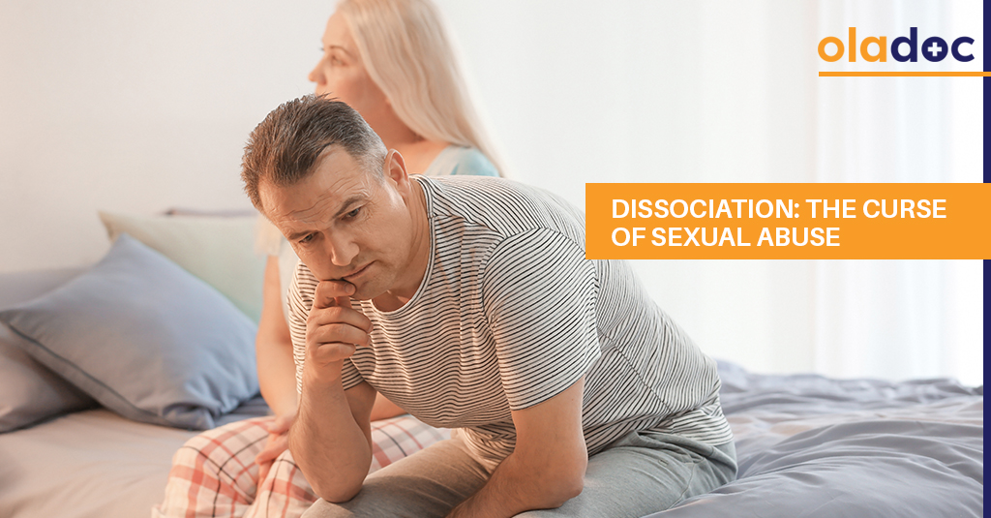 https://s3-us-west-1.amazonaws.com/oladoc-articles/images/2019/01/Dissociation-The-curse-of-sexual-ab.jpg
Dissociation is a defence mechanism the brain uses to cope with traumas of sexual exploitation. It involves an out of body experience that deviates one from reality.
Panic Attacks
A panic attack involves a sudden feeling of intense fear and anxiety. It happens in scenarios where there is no impending danger and could last between five and thirty minutes although it could take an hour or more. The image below shows a lady having panic attacks which are closely linked to sexual exploitation after-effects.
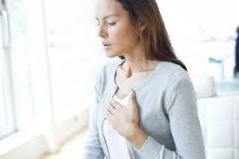 https://images.app.goo.gl/AEaPuc1BKabu9jT6A
Panic attacks are common among survivors of sexual violence and could range from having chest pains, hot flashes, and chills, feeling out of breath, dizziness, fast pounding heartbeats and feelings of danger.
Pregnancy
Oftentimes sexual exploitation survivors particularly women will end up being pregnant after being sexually exploited. There are also several medical issues like contracting sexually transmitted infections that comes with a pregnancy after sexual exploitation. The image below shows a teenager who is pregnant following an act of sexual exploitation.
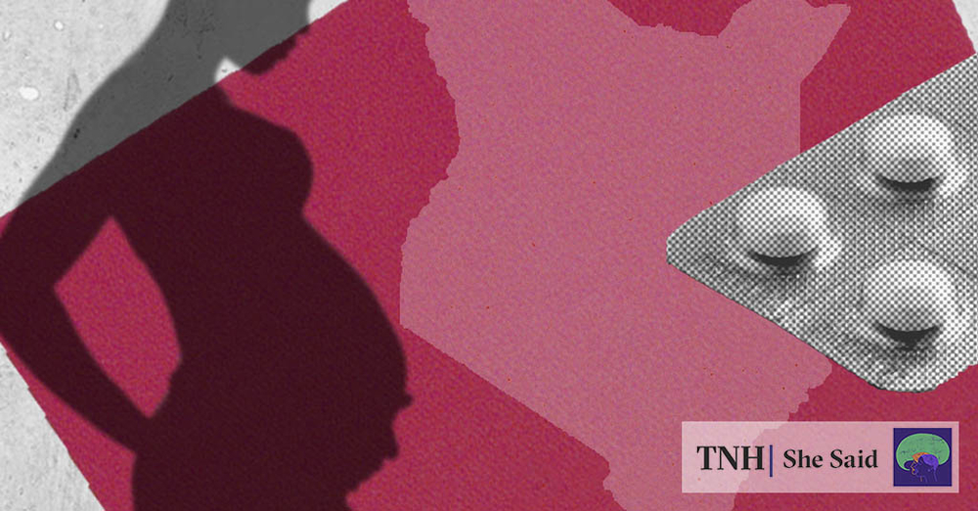 https://assets.irinnews.org/s3fs-public/styles/responsive_large/public/kenya-pregnancy-graphic-thumbnail-she-said.jpg?CfgFm0URqRghvQXFtRVHUhA9dQYlljOr&itok=rHALELq6
Sleep Disorders
Sleep disorders also result from sexual exploitation. The disorders could result in the survivor having interfered sleep patterns, sleeping at unusual times of the day, longer or shorter hours of sleep and staying awake the whole night. Some individuals could have sex-somnia, insomnia, sleep terrors and nightmares. The image below shows an individual with sex-somnia. The individual experiences sex-related acts and exhibits sex-related behaviours while asleep while he/she might not necessarily be engaging in sex in reality.

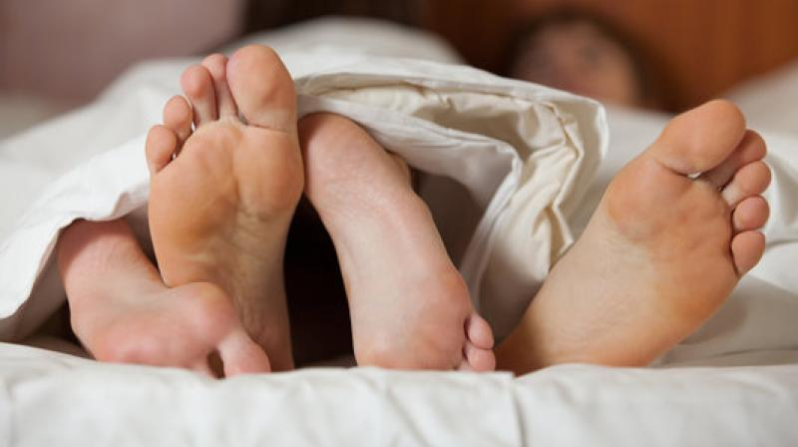 https://dc-cdn.s3-ap-southeast-1.amazonaws.com/dc-Cover-10gi5bc5h293rllj8n5rukjq33 20160613145237.Medi.jpeg
Suicide
Suicide is a common impact of sexual exploitation. Survivors tend to feel unworthy and ashamed and this lowers their self-esteem forcing them to consider terminating their own lives. These survivors think the only way to forget about what happened to them is failing to exist otherwise their existence will always be a constant reminder of what they went through. The image below shows the percentage of sexual exploitation survivors who contemplate suicide and those who attempt.
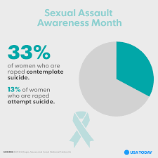 https://encrypted-tbn0.gstatic.com/images?q=tbn:ANd9GcQbiaj-axZs9DWx8F4ML7tYf67U3P5X-eE3Jg&usqp=CAU
Depression
Depression is a mood disorder which results from long periods of hopelessness and sadness which ultimately disrupt an individual’s normal thought patterns. Sexual exploitation causes its survivors to experience sadness, hopelessness and at times self-hatred and as a result these individuals become depressed. Discrimination affects people of all ages, races and gender. The image below depicts a woman who is depressed after being sexually exploited. The survivor feels lonely and unhappy. She is deep thoughts.
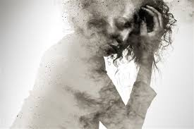 https://media3.s-nbcnews.com/j/newscms/2017_16/1971636/170420-stress-mn-1610_0f3e8dbc9612f49c79ab764aa4ad0895.fit-760w.jpg
Flashbacks
Flashback is a common effect of sexual exploitation. It involves the survivor having memories of a past sexual trauma feel as if it was taking place in the current moment. The survivor therefore feels like the past sexual exploitation act is happening now. During a flashback the survivor finds it very difficult to connect with reality. He/she may even feel as though the perpetrator is physically present. Flashbacks can be triggered by ordinary experiences linked with senses. They could include the smell of a particular tonal voice that sounds like the perpetrator’s or even a smell of one’s odour that feels like the perpetrators. Below is an image of a woman who has flashbacks of an act of sexual exploitation undertaken against her when she was a little child yet it persists into adulthood.
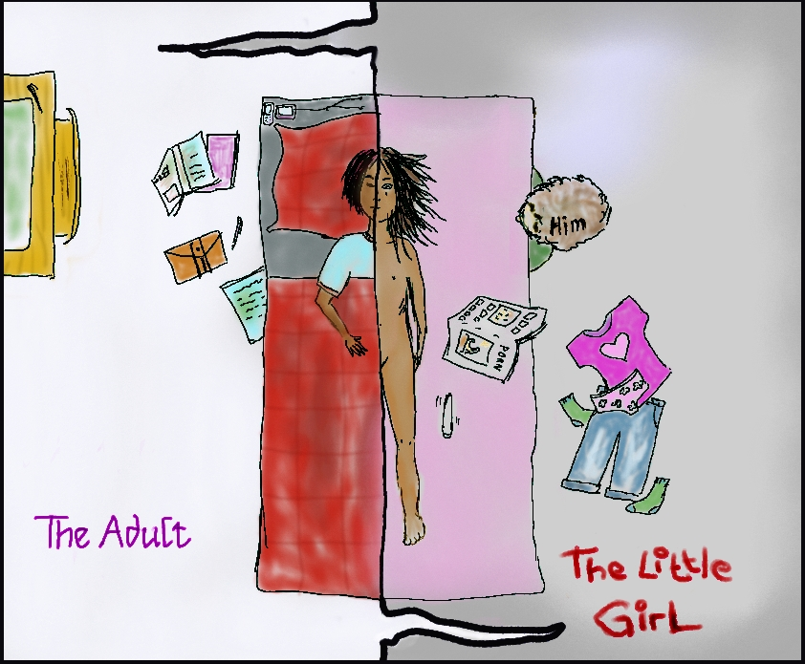 https://whatittakes2bme.files.wordpress.com/2009/08/sexual-abuse-flashback.jpg
Post-Traumatic Stress Disorder
It’s normal for survivors of sexual exploitation to experience feelings of anxiety, stress, and fear. In case these feelings increase in frequency and severity, lasting for more than a number of weeks and begin interrupting an individual’s day-to-day, the individual develops post-traumatic stress disorder. The image below shows a stressed woman who is feeling sad and unwanted because of a sexual trauma she underwent. The disorder could involve the survivor re-experiencing the act, engaging in avoidance behaviours and at times having a hyper-arousal.
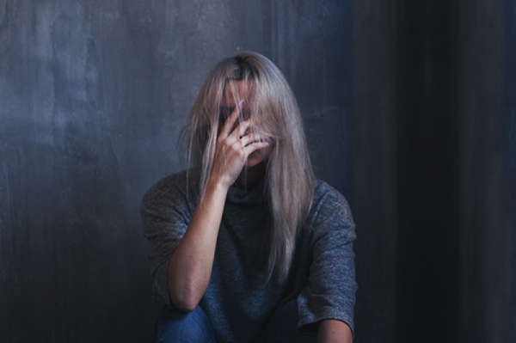 https://dxe4ut1yp4dmw.cloudfront.net/79846-ptsd-conditionimage-lg.jpg

References
https://assets.irinnews.org/s3fs-public/styles/responsive_large/public/kenya-pregnancy-graphic-thumbnail-she-said.jpg?CfgFm0URqRghvQXFtRVHUhA9dQYlljOr&itok=rHALELq6
https://dc-cdn.s3-ap-southeast-1.amazonaws.com/dc-Cover-10gi5bc5h293rllj8n5rukjq33 20160613145237.Medi.jpeg
https://dxe4ut1yp4dmw.cloudfront.net/79846-ptsd-conditionimage-lg.jpg
https://dxe4ut1yp4dmw.cloudfront.net/79846-ptsd-conditionimage-lg.jpg
https://encrypted-tbn0.gstatic.com/images?q=tbn:ANd9GcQbiaj-axZs9DWx8F4ML7tYf67U3P5X-eE3Jg&usqp=CAU
https://images.app.goo.gl/AEaPuc1BKabu9jT6A
https://media3.s-nbcnews.com/j/newscms/2017_16/1971636/170420-stress-mn-1610_0f3e8dbc9612f49c79ab764aa4ad0895.fit-760w.jpg
https://s3-us-west-1.amazonaws.com/oladoc-articles/images/2019/01/Dissociation-The-curse-of-sexual-ab.jpg
https://thewellproject.org/sites/default//files/STD.jpg
https://whatittakes2bme.files.wordpress.com/2009/08/sexual-abuse-flashback.jpg
https://www.sovarizona.com/wp-content/uploads/2015/06/substance-abuse-sexual-exploitation.jpg

